

Appealguru

Client-Employee Management system



May 16, 2021

Interns project

**INTRODUCTION**

Appeal Guru Employee Management is a system developed for managing employees. It is an online website which is dedicated towards maintaining employee and client data. This website will support all the popular web browsers.

This system will be designed to overcome the problem faced in the traditional method of managing employee’s data in books, maintaining attendance sheet, maintaining client data in books, maintaining daily records in books and many more. So, to overcome this problem this system will be developed where each and every task will be done through website and we can also access this anywhere around the globe with active internet connection.

This system will help manager to manage employee and client data, assign task to employee, communicate with clients and employees using chat or video call through zoom, client can raise ticket if they have any issue and manager can upload salary slip for employee.

**REQUIREMENT GATHERING**

* Login
* Logout
* Change password
* Update profile (view profile)
* Manage employee data (add,update,remove)
* Manage client data (add,update,remove)
* Communication between employee and client(chat application)
* Communication between employee and manager(chat application)
* Communication between client and manager(chat application)
* Employee can view his attendance (tabular form)
* Manager can view his as well as employee's attendance (tabular form)
* Employee can view salary slip generated by manager
* Manager can add,update,remove salary slip of employee
* Employee can view past leave and apply for leave
* Manager can approve or reject leave
* Client can raise complaint tickets
* Team leader can view complaints raise on his team members
* Team leaders can view team member
* Manager can view all the tickets(unsolved) raised by clients on which team does that tickets belong
* Manager can give warning to the employees
* Employee rating
* Automatic user logout idle timeout of 10 minutes
* Employee screen recorder (from login to logout)
* Employee can generate invoice
* Manager can view/edit invoice
* Employee can view attendance
* Manager can view attendance of employees

**USERS**

Types of users:

1. Client
2. Employee
3. Team Leader
4. Manager
5. **Client:**

* Login
* Logout
* Manage profile(update)
* Communicate with employee/manager(chat application)
* View/raise ticket
* Raise ticket table

1. **Employee:**

* Login
* Logout(idle timeout 10 minutes)
* Manage profile(update)
* Communicate with client/manager(chat application)
* View/resolve ticket
* Can view attendance
* Can view salary slip
* Can view past leave
* Can apply for leave
* Resolve tickets table
* Group chat application

1. **Team leader:**

* Login
* Logout(idle timeout 10 minutes)
* Manage profile(update)
* Can view team members
* Communicate with client/manager(chat application)
* View/resolve ticket
* Can view attendance
* Can view salary slip
* Can view past leave
* Can apply for leave
* Resolve tickets table
* Group chat application

1. **Manager:**

* Login
* Logout(idle timeout 10 minutes)
* Manage profile(update)
* Manage team leaders(add,update,remove)
* Manage employees(add,update,remove)
* Manage client(add,update,remove)
* View attendance of employee
* Generate salary slip of employee
* View/accept/reject leave
* View employee report
* Manager can communicate with clients/employees(chat application)
* Group chat application
* Connect Client to Employee

**WIREFRAMES**

1. **Login Page:**

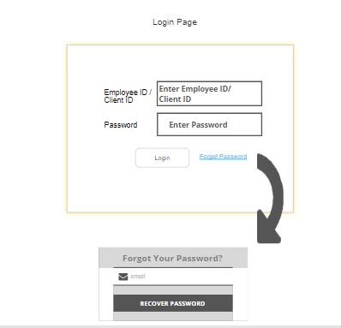

1. **Client:**

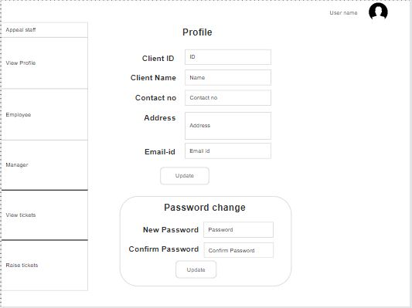

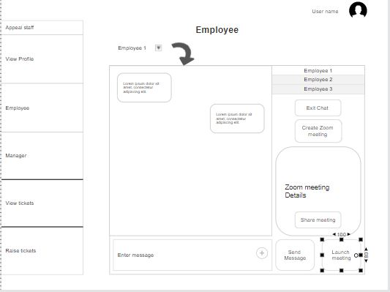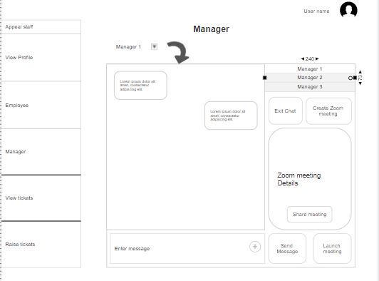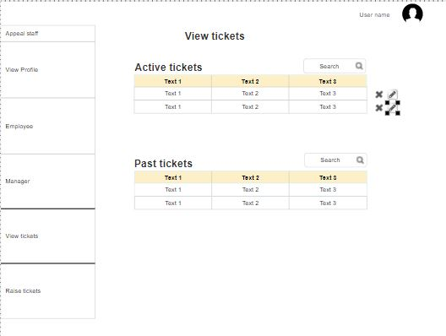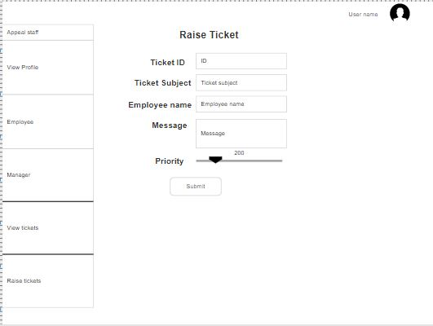

1. **Employee and Team Leader:**

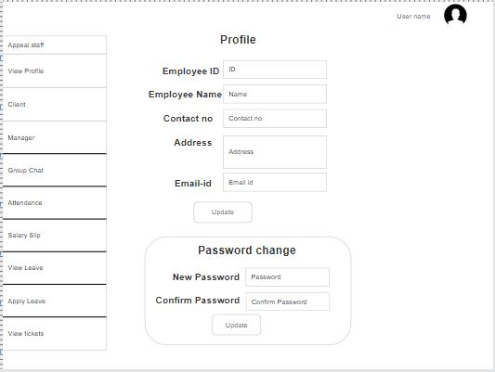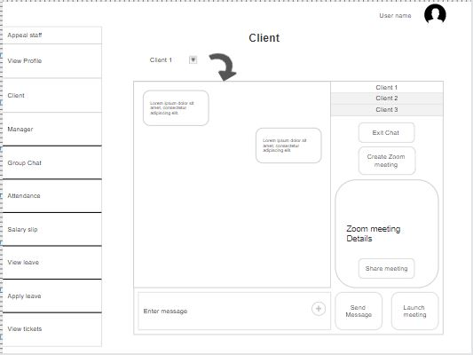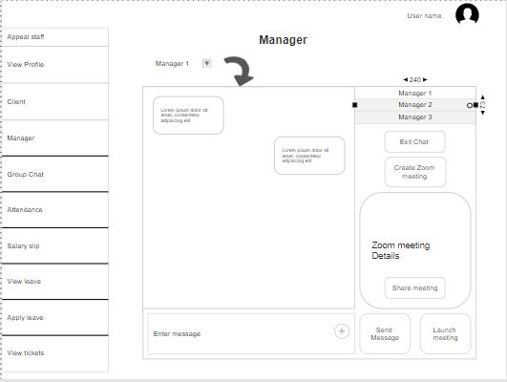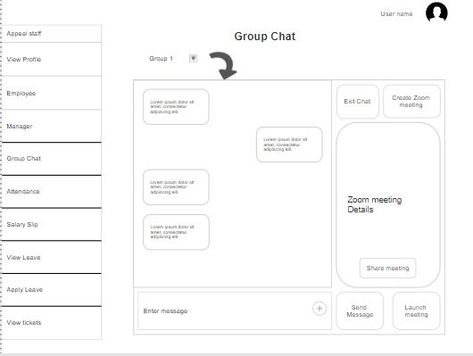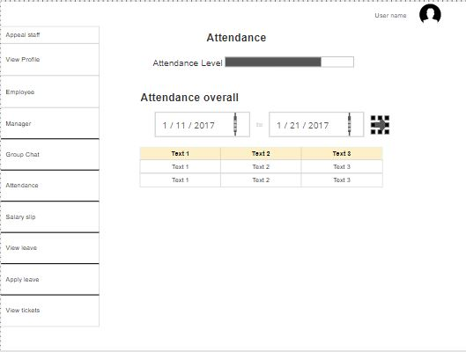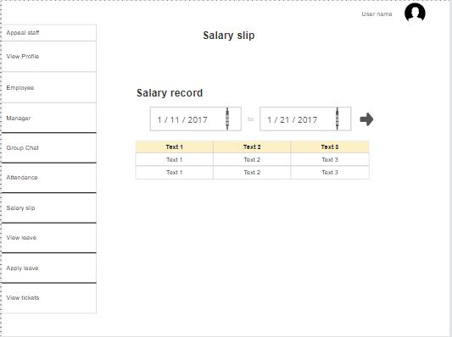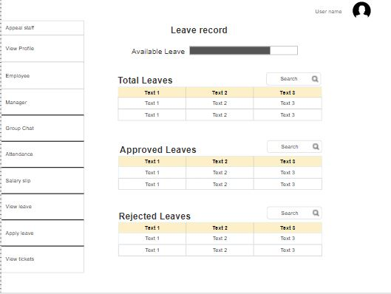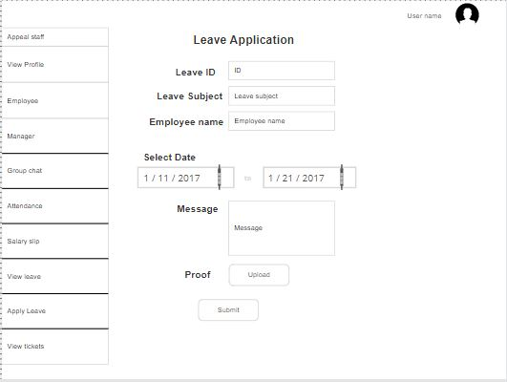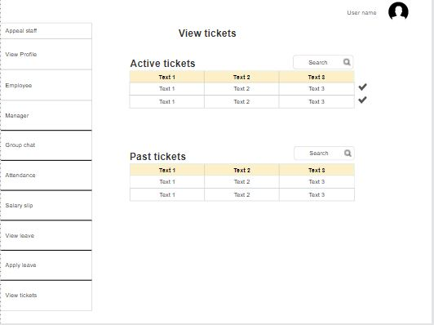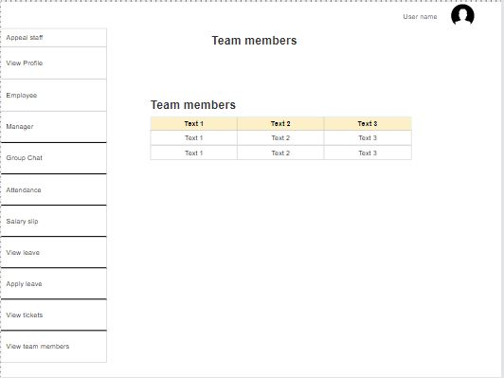

1. **Manager:**

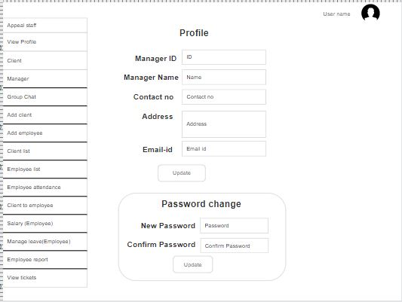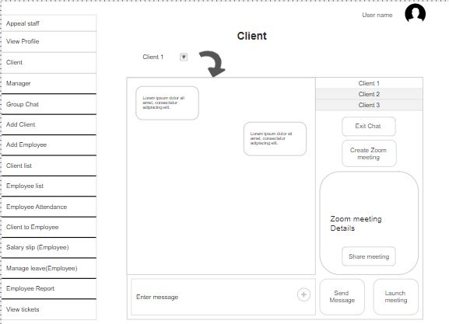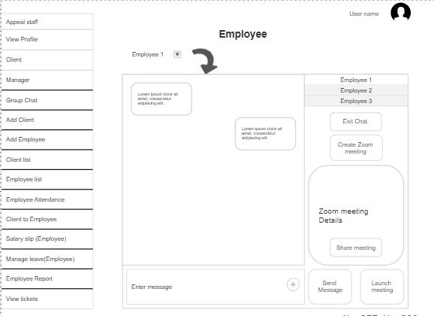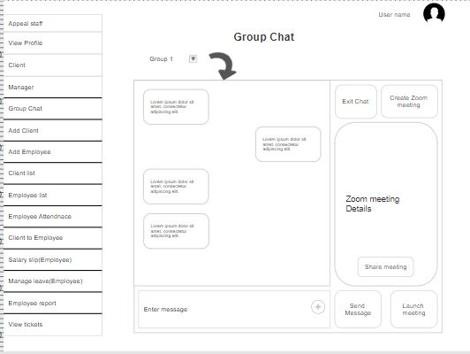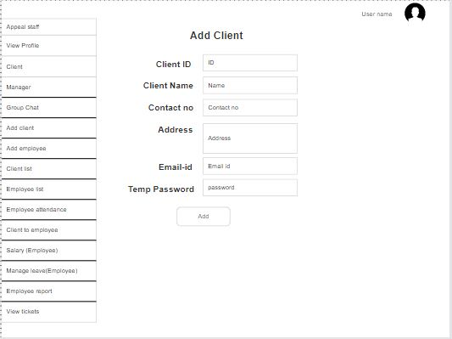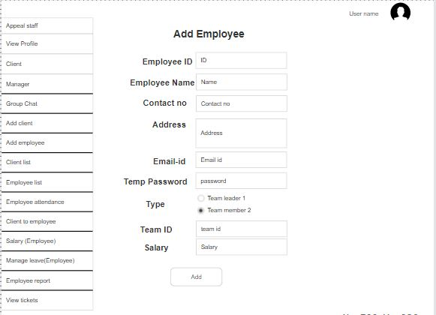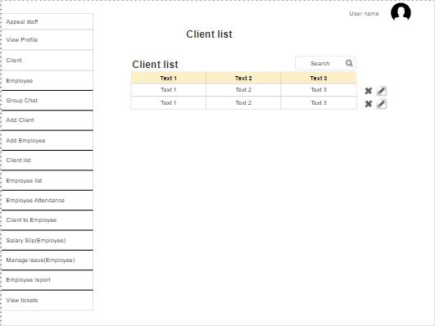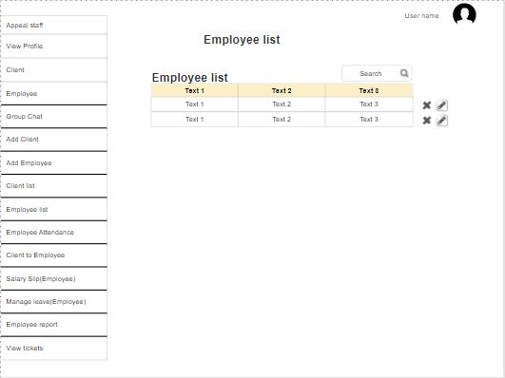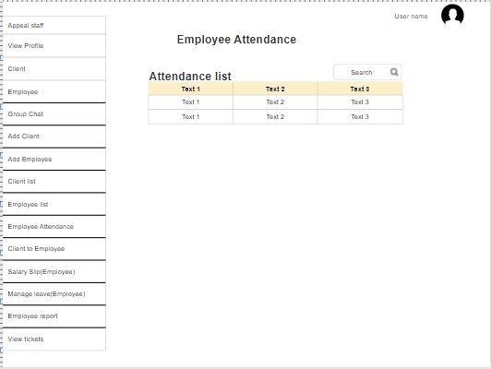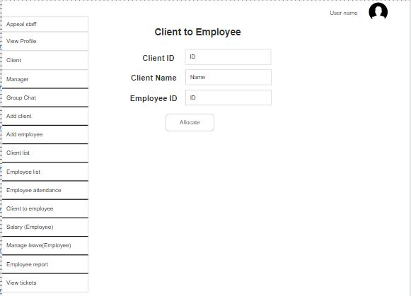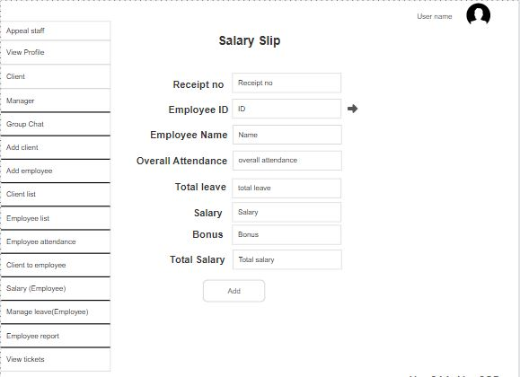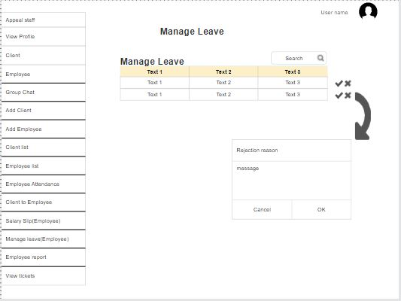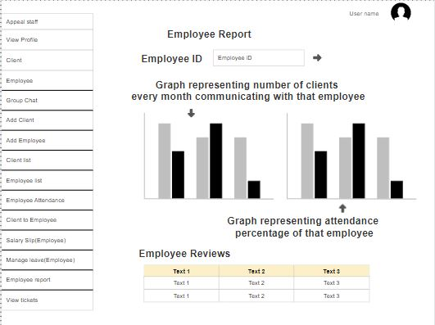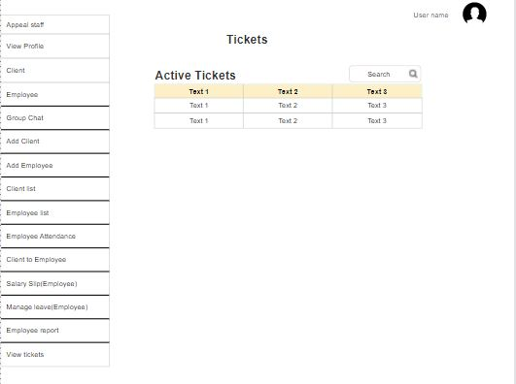

**PAID THINGS**

1. Domain (If there is no sub domain available).
2. Hosting (If windows hosting is not available in sub domain).

Here are the plans of 1yr, 5yrs and 10 yrs for domain and hosting with unlimited space and windows hosting if above service are not available.







**Note: Domain name is just for reference.**